Pro Writer Lite Plugin

Welcome, and thank you for using our plugin. You can now edit pages and posts without needing to enter the admin. Our plugin activates automatically, and will add a new
option 'Edit Page Content' in your admin bar when you are viewing individual blog posts and pages.

Pro Writer Lite ghosts out shortcodes, which will prevent you from overwriting important page codes while editing your posts from the front-end.

We offer a professional version of our plugin on our website with more functions in a secondary menu which will allow you to create columns, add bullet points, buttons and more. The pro version of our plugin also works with shortcodes, allowing you to edit your pages with all extended functionality visible in edit mode.
We are adding more features all of the time. You can learn more about the professional version of our plugin here: http://prowriter.co,

Activating edit mode will change the background color of all editable regions to a light gray. You can now add and edit copy and include images, videos and more without ever needing to go into the WordPress back-end. Selecting text or lines in this area will bring up a new menu that will allow you to style text, make headlines or add images and embeds.
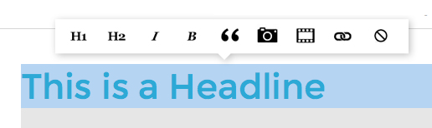

To add an image or video, create a new line and double click it. Select the camera icon to add WordPress images, or the movie icon to add You Tube videos, Google maps, and some other third-party scripts.

When you are finished, select 'Save Page Content' to save your post.

